12/15/2017

Installing the Replacement Low Fuel Sensor for 2014 -2017

Remove the Fuel Tank
- Remove RH and LH Leg Guards (if installed)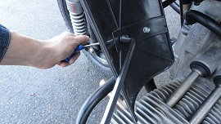
- Remove fuel hose from LH side of the fuel pump.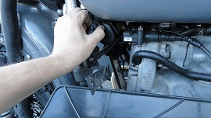
- Install a piece of hose onto the fuel pump and direct it into a fuel canister.
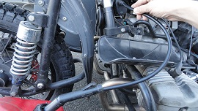

- Turn on the ignition with the kill switch in “Run” position to start the flow of fuel. Turn off the ignition and allow the fuel to continue to drain as much as possible. Turning the ignition back on and using the pump to remove the fuel may increase the rate of flow, but use caution and never leave the motorcycle unattended to drain with the key on. Do not allow the pump to run dry. Even 30 seconds of dry operation can severely damage the pump.
- Place a tray underneath the motorcycle to catch fuel that may spill out when removing the additional hoses.
- Remove the rear seat and seat support plate.
- Remove the negative (-) battery cable from the battery.
- Disconnect the two fuel lines from the RH side of the fuel pump.
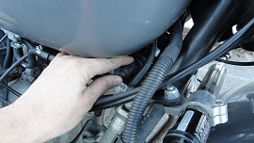
- Disconnect the cross tube and plug the fuel lines.
- Remove the two M8 bolts from the front of the fuel tank.
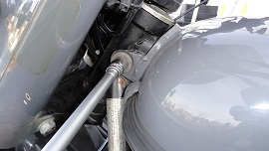

- Disconnect the small 3-pin connector of the low fuel sensor.
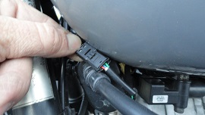
- Remove the fuel tank by lifting the front of the tank slightly first, then lifting the rear of the tank back and up. Use caution. There may still be a notable volume of fuel left in the tank and could spill when moving the tank.
- Drain the rest of the fuel from the tank and confirm that the fuel is completely drained. Tank is now removed.

Replace the Low Fuel Sensor
- Remove the old sensor from the fuel tank using a 19mm Box Wrench. Save for next steps.
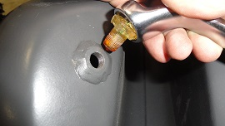
- Prepare a piece of Mechanic’s Wire (or bailing wire, welding wire, etc.) about 60cm long, with an arch and hook to hold onto.
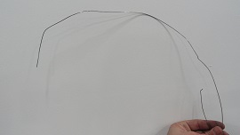
- Insert the wire into the sensor hole and pull it through the filler hole using your finger or a hook.
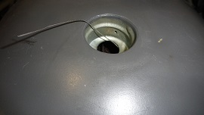
- Use a small piece of electrical tape to securely attach the ends of the sensor wires to the Mechanic’s Wire.
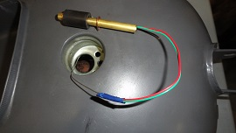
- Gently lower the sensor into the filler hole and install the fuel cap.
- Flip the tank over and gently lift the Mechanic’s Wire and sensor until the sensor’s circlip is lightly seated against the inside of the fuel tank.
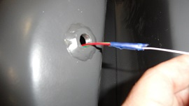
- Apply a light coating of Grey Gasket Maker to the first few threads of the M12 adapter fitting.
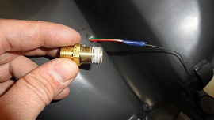
- Install the M12 adapter fitting over the wires and tighten into the fuel tank with a 9/16^{-inch} wrench until very tight and about 12mm of the sensor stem can protrude through the fitting when gently lifted.
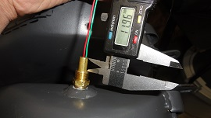
- Hold the sensor in place by lightly pulling up on the wires while you install the compression olive and compression nut.
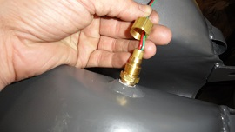
- Ensure that the sensor is in the correct position with the circlip lightly resting on the inside of the tank before tightening the compression nut, as the olive is one-time-use and cannot be removed and installed again. Use a 9/16^{-inch} wrench to tighten the compression nut until it starts to crush the olive, then tighten an additional 1/3 turn to create the seal.
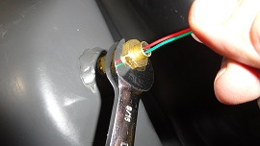

- Cut the old sensor lead wires about 10cm from the connector.
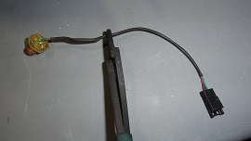
- Strip back 2cm of the outer insulation.
- Cut away the blue wire as close to the connector as possible. The blue wire is no longer used, but should be cut away to prevent it from contacting ground.
- Strip away 8mm insulation from the red and green wires.
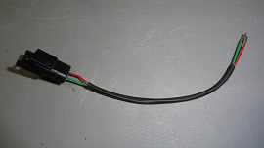
- Install the butt connectors, connecting red-red and green-green wires. Crimp with insulated terminal crimping pliers designed for 18-22GA insulated terminals (usually indicated by red mark.) Make sure that both the center metal terminal and outer insulation are crimped creating a mechanical and electrical connection and a water-tight seal. The seal will cure in 3 hours and no heating is required. Lightly tug on the wires to make sure the crimp is mechanically sound. Do not apply heat to the butt connectors.
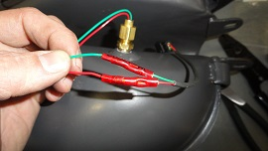

- Wrap the loose wires with a high-quality electrical tape.
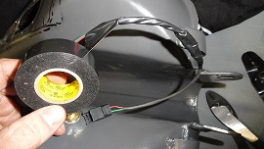
- Make sure the fuel tank lines are plugged, and fuel cap is installed.
- Temporarily re-connect the negative (-) battery cable.
- Plug in the low fuel sensor connector. Turn the engine kill switch to “stop” position to prevent the fuel pump from turning on. Turn the ignition key to “on” and check the low fuel indicator lamp for correct function. When holding the empty tank upright, light should be on, and when holding it upside-down, light should be off. When checking, you may need to give the tank a shake because the dry float might not slide easily on the post, but it will work normally in operation. Turn the ignition key off.
- Disconnect the negative (-) battery cable.
- Re-install the fuel tank making sure all fuel lines are securely in place.
- Connect the negative (-) battery cable. Turn the engine kill switch to “stop” position to prevent the fuel pump from turning on. Turn the ignition key to “on” and check the low fuel indicator lamp for correct function. The indicator should be on when the tank is empty. Start filling the tank with fuel and carefully check for any leaks at the sensor and fuel lines. If sensor or adapter fitting is leaking, tighten with a 9/16^{-inch} wrench until the leak is stopped. Fill the fuel tank with fuel and make sure the low fuel indicator lamp goes out before the tank is about 1/3 full.
- Re-install the seat plate and seat.

- Follow normal procedures for bleeding the fuel lines after running out of fuel before attempting to start the motorcycle. This involves running the pump for a short time and then releasing the air from the high-pressure line by releasing the fitting of the left side of the fuel pump. You may need to repeat this operation until the air is released from the pump and lines. Do not allow the pump to run dry. Even 30 seconds of dry operation can severely damage the pump.

